1. LINQ Empty Method in C#:

The Empty method in LINQ generates an empty sequence of a particular type. This method is useful when you need to return an empty sequence from a method without returning null or when you need to start with an empty sequence and conditionally populate it with elements based on further logic.

The LINQ Empty Method in C# is a static method included in the static Enumerable class. The Empty Method returns an empty collection (i.e., IEnumerable<T>) of a specified type. The following is the signature of this method.



Here, TResult specifies the type parameter of the returned generic IEnumerable<TResult>. This method returns an empty IEnumerable<TResult> whose type argument is TResult.

1. Example to Understand Empty Method in C#:

Let us see an example of the LINQ Empty Method in C#. In the following example, we have created two empty collections using the LINQ Empty Method. The first Empty method returns an empty collection of strings, while the second Empty method returns an empty collection of students.

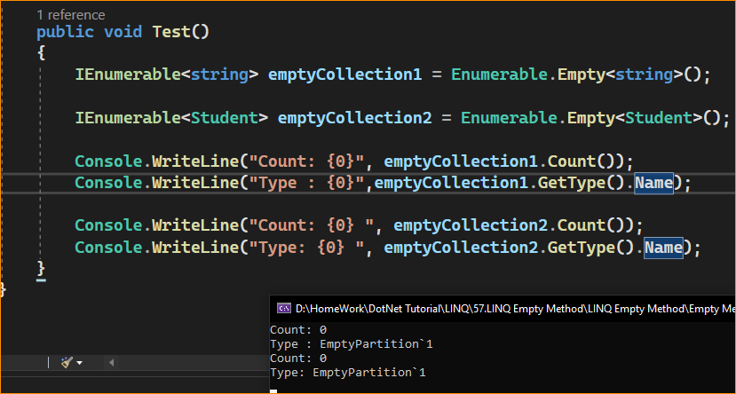

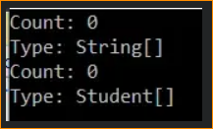

1. Why do we need the Empty Method in C#?

Let us understand the need for the LINQ Empty Method in C# with an example. Consider one scenario where our application calls a method that returns an IEnumerable<int>. There might be a situation where the method returns null. In the following example, the GetData() method is returning null. So, when we run the following program, it will throw a NULL Reference Exception.

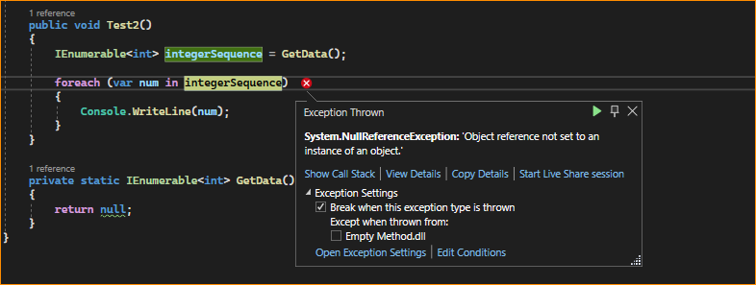

* Solution1: Checking Null Before using inside the Loop

We need to check for NULL before looping through the items in the collection, as shown in the below example.

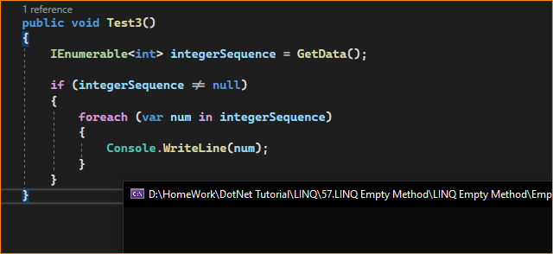

* Solution2: Using the Empty Method

We can solve the problem using the LINQ Empty Method, as shown in the example below. Here, we use the NULL-COALESCING operator, which checks if the GetData() method returns NULL, then initializes the integerSequence variable with an empty IEnumerable<int>.

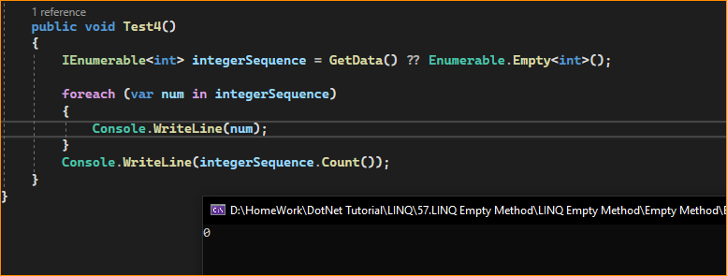

While the Empty method is not as commonly used as other LINQ methods like Where, Select, or OrderBy, it can be useful in scenarios where you need to initialize sequences or collections without any initial data but of a specific type.

1. When to Use the LINQ Empty() Method in C#?

The Enumerable.Empty<T> method in C# LINQ is typically used when creating an empty sequence or collection of a specific type. It is useful when you require an initial empty collection to work with or as a placeholder. Here are some common situations where you might use the Enumerable.Empty<T> method:

**Initializing an Empty Sequence:**

When you need to start with an empty sequence of a particular type before populating it with data dynamically, this is common when building LINQ queries or initializing collections for later use.

Use Case: When you need to initialize a variable to an empty sequence to ensure that subsequent LINQ queries or operations do not throw a NullReferenceException.

Example: IEnumerable<int> numbers = Enumerable.Empty<int>();

**Placeholder for Default Values:**

In some cases, you may need to provide a default value for an operation or return a known empty sequence as a result. Enumerable.Empty<T> can be used for this purpose.

var result = GetResults() ?? Enumerable.Empty<ResultType>();

Testing for Empty Collections: You can use Enumerable.Empty<T> when writing unit tests or validations to ensure your code handles empty collections correctly. It allows you to create empty collections for testing easily.

var emptyCollection = Enumerable.Empty<string>();

// Perform tests with the empty collection

**Providing Default Data:**

When working with methods that require input data but can also accept empty data, you can use Enumerable.Empty<T> as a default value to represent the absence of data.

**var data = GetData() ?? Enumerable.Empty<DataItem>();**

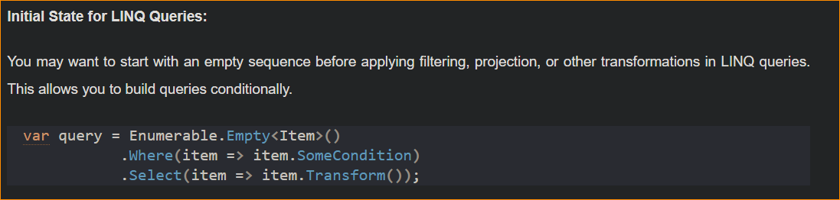

**Placeholder for Deferred Execution:**

In scenarios where you want to defer execution of a LINQ query until later but need to create a placeholder for the query, Enumerable.Empty<T> can be used as a starting point.

var deferredQuery = Enumerable.Empty<Item>().Where(item => item.SomeCondition);

**Empty Sequences for Aggregation:**

When aggregating data from multiple sources or needing an initial empty sequence to collect data, you can use Enumerable.Empty<T> as a starting point for aggregations.

var aggregatedData = sources.Aggregate(Enumerable.Empty<DataType>(), (acc, source) => acc.Concat(source.Data));

**Default or Fallback Values**

Providing a default or fallback value in a conditional expression, particularly in ternary or null-coalescing operations.

Example: var results = someCondition ? GetData() : Enumerable.Empty<Data>();

**Concatenating Sequences**

When you want to concatenate sequences conditionally and need an empty sequence to start with.

Example: Concatenating user permissions where a new user might start with no permissions:

var permissions = Enumerable.Empty<Permission>().Concat(additionalPermissions);

**Avoiding Null Collections**

When you want to guarantee that a collection property is never null, to avoid the need for null checks elsewhere in your code.

Example: In a class constructor where collection properties are initialized to Enumerable.Empty<T>() rather than left as null.

In summary, Enumerable.Empty<T> is valuable when you need to create empty sequences or collections of a specific type for various purposes, such as initialization, testing, handling default values, or serving as a placeholder for data. It allows you to work with empty collections in a type-safe manner and is particularly useful in LINQ queries and deferred execution scenarios.